[amitnehe0912@gmail.com](mailto:amitnehe0912@gmail.com)

+91 9325929635

software professional for growth of organization and myself.

2021- 2023

**C++ JAVA**

2018 - 2021

2017 - 2018

2015 - 2016

*Operating Systems*

*Languages*

•

Online Restaurant website

**Multitasking & Creative**

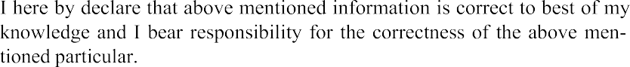

**Objective**:1. Online Restaurant website” is a website for a restaurant to

provide their customers various services, besides the delicious food, for their

convenience.

2. Unlike years ago, where everything was traditional, when people used to come to the restaurant, then view the Menu ,get their order written and pay in cash.

**Technologies: Java,Html,My SQL**

☐